**MongoDB and NoSQL**

**DATABASE:**

A database is an organized collection of data stored electronically. It allows users and applications to easily access, update, and manipulate information. This data contains text, numbers, images, videos and more. Databases are managed using specialized software known as a Database Management System (DBMS), which facilitates the storage, retrieval, and manipulation of data.

**Types of Database Management System:**

There are mainly five types of databases. They are given below.

* Relational Database management system
* Network Database system
* Hierarchical Database System
* Object-oriented Database System
* **NoSQL(Non-Relational) databases**

**NOSQL:**

The NoSQL system or "Not Only SQL" is essentially a database that is made specifically for unstructured and semi-structured data in very large quantities. Unlike Conventional Relational Databases, where data are organized into tables using predefined schemas. NoSQL allows flexible models to be organized and horizontally scalable.

**Why Use NoSQL?**

Unlike relational databases, which use Structured Query Language, NoSQL databases do not have a universal query language. In fact, each NoSQL database has its own approach to query languages. Traditional relational databases will follow ACID principles, assuring a strong consistency and a structured relationship between the data.

The needs of applications have been changing through time, due to increased requirements related to big data, real-time analytics and distributed environments NoSQL emerged to satisfy:

* **Horizontal Scalability:** Add more nodes instead of upgrading hardware.
* **Schema Flexibility:** Supports unstructured/semi-structured data without rigid schema.
* **High Performance:** Fast read/write for large datasets.
* **Distributed Architecture:** Ensures high availability and partition tolerance.

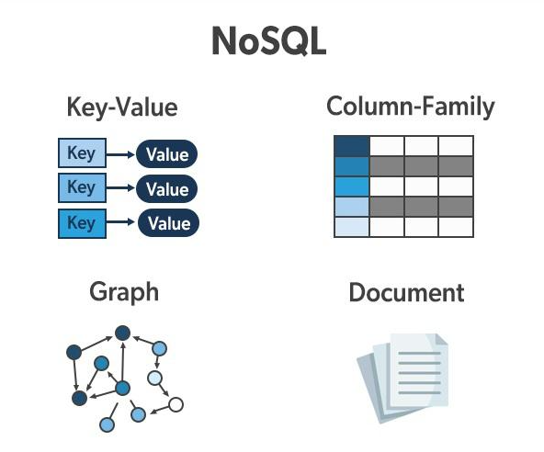

**TYPES OF NOSQL DATABASES**

**1. Document Databases**

Store data as JSON, BSON, or XML documents.

Example: MongoDB, CouchDB

**2. Key-Value Databases**

Store data as key-value pairs.

Example: Redis, DynamoDB

**3. Column-Family Databases**

Store data in columns instead of rows; great for large-scale analytics.

Example: Apache Cassandra, HBase

**4. Graph Databases**

Store data as nodes and relationships; ideal for networked data.

Example: Neo4j, ArangoDB

**Types of NoSQL Databases and Their Key Features:**

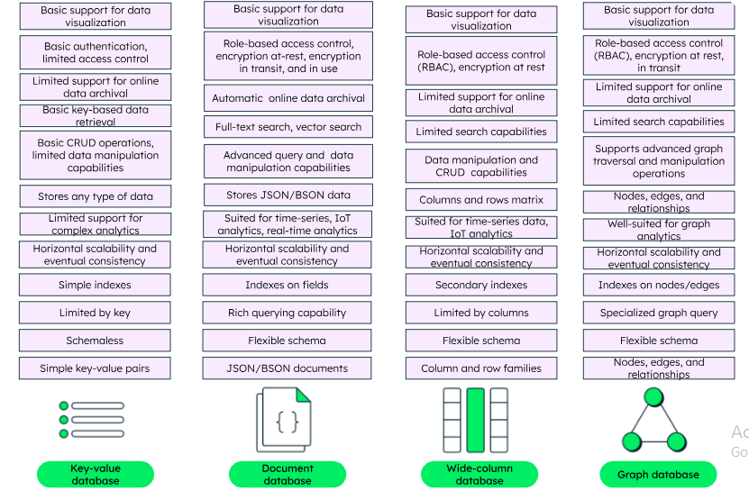

**MongoDB**

**Origin of MongoDb:**

MongoDB was founded in 2007 by **Dwight Merriman, Eliot Horowitz**, and **Kevin Ryan**, former leaders at DoubleClick (acquired by Google). Frustrated by the scalability limits of relational databases, they aimed to create a more flexible, scalable, and developer-friendly data platform.

Originally launched as 10gen, the team developed **MongoDB** (short for **“humongous database“**) using a document-based model suited for high-volume, unstructured data. With the rise of cloud computing, they saw an opportunity to build a modern, open, and developer-centric platform.

**MongoDb:**

MongoDB is a NoSQL (non-relational) document-oriented database that stores data in flexible, JSON-like documents (BSON). It’s designed for high performance, scalability, and ease of development, especially for modern web and mobile applications.

**Uses of MongoDB**

MongoDB is used when applications require:

* Flexible schema (fields can vary across documents)
* Scalability (can handle huge volumes of data)
* Real-time performance (fast read/write)
* High availability (via replication)
* Horizontal scaling (via sharding)

**Real-World Applications Using MongoDB**

Here’s how MongoDB is used in various industries:

**1.E-commerce (e.g., eBay, Flipkart)**

Product catalogs with varied attributes

User carts and wish lists

Order tracking with event logs

**2.Social Media & Content Platforms (e.g., LinkedIn, Pinterest)**

User profiles, posts, comments, reactions

Feed generation

Metadata and tag-based content search

**3.Mobile Applications (e.g., Uber, Delivery Apps)**

Real-time location tracking

Booking history

Notification and chat systems

**4.Healthcare (e.g., GE Healthcare)**

Patient medical records (dynamic fields)

Wearable device data (real-time & varied structure)

Medical imaging and diagnostics logs

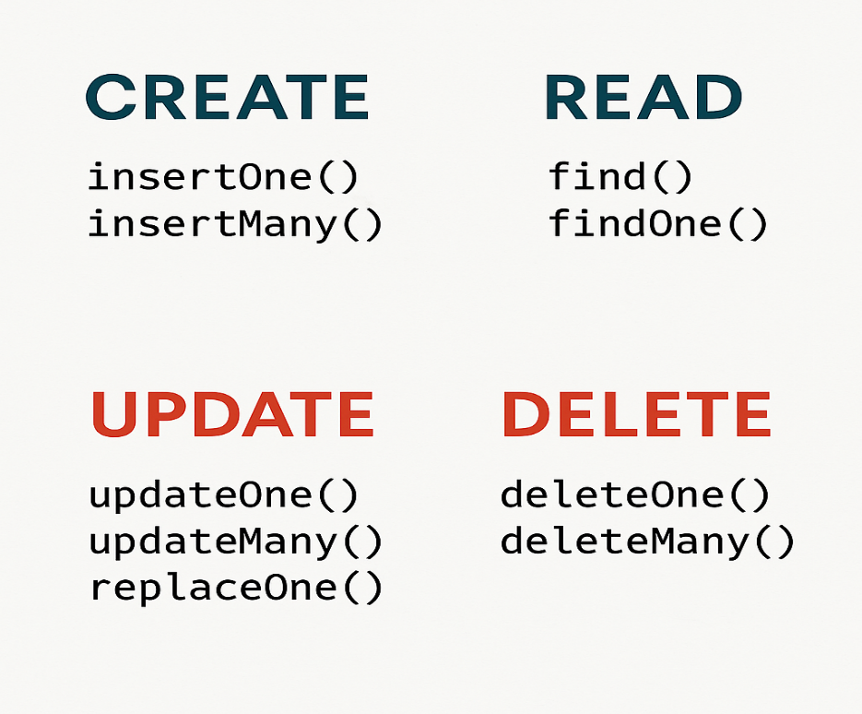**CRUD Operations:**